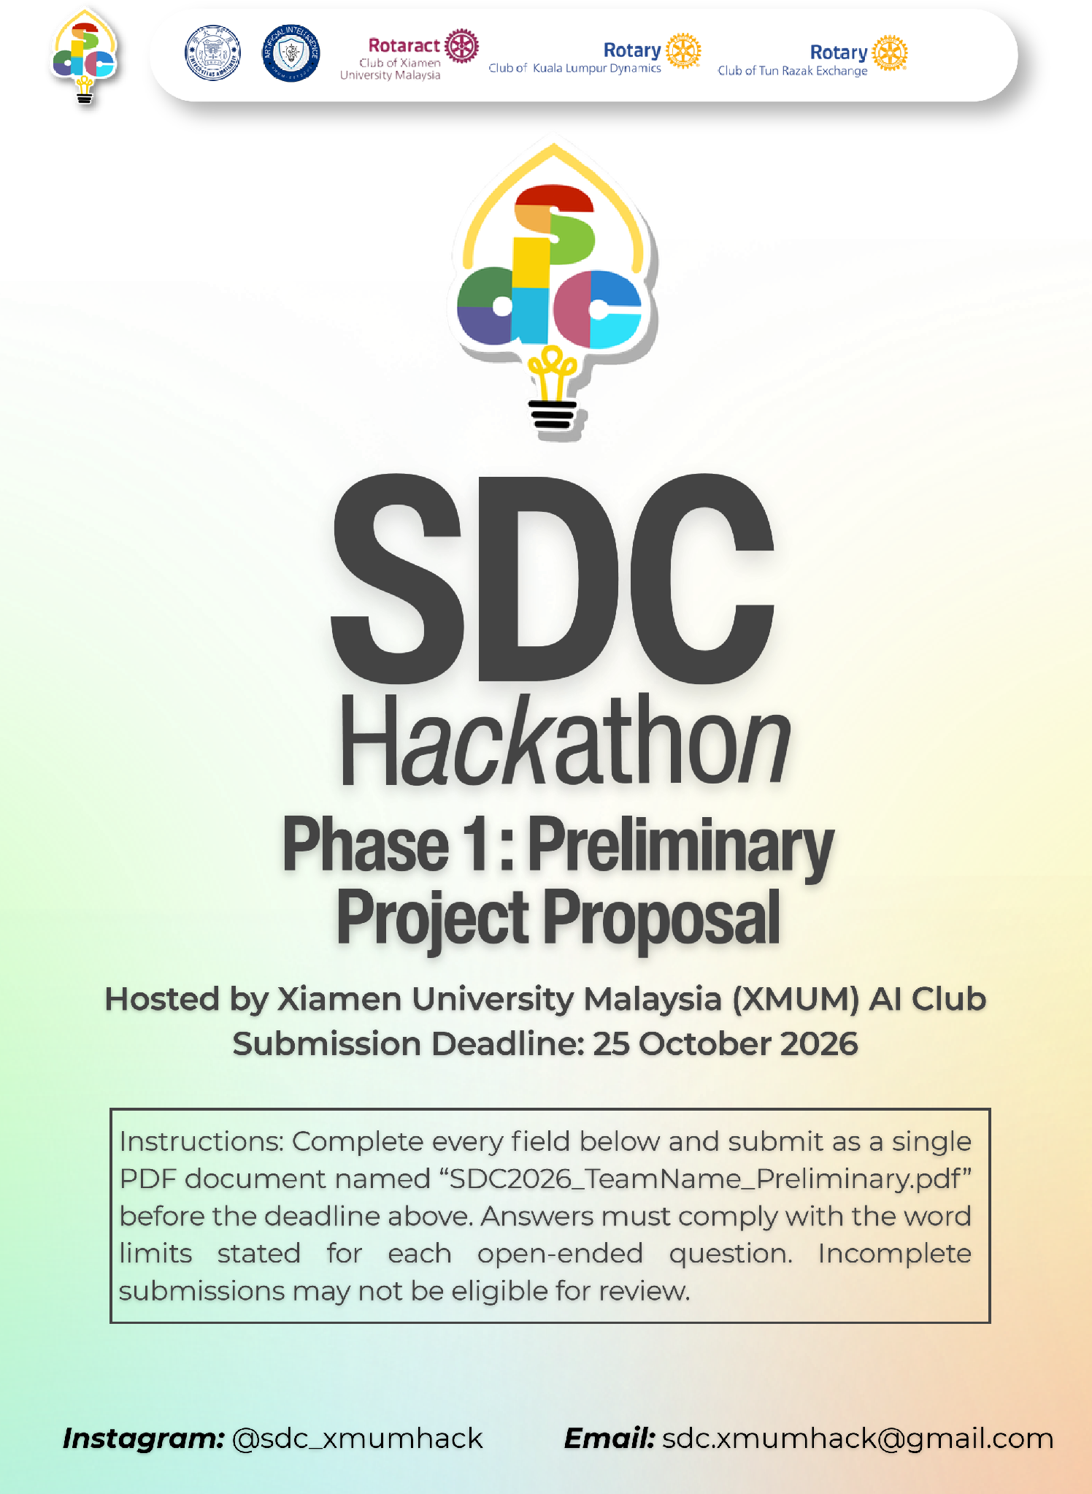
SDC HACKATHON 2026
Phase 1: Preliminary Project Proposal
Hosted by Xiamen University Malaysia (XMUM) AI Club
Submission Deadline: 25 October 2026
Instructions: Complete every field below and submit as a single PDF document named “SDC2026_TeamName_Preliminary.pdf” before the deadline above. Answers must comply with the word limits stated for each open-ended question. Incomplete submissions may not be eligible for review.

1. Team & Project Overview
Team Name | 418 I'm a Teapot

Selected Domain | Domain1

Selected SDG Track (1–17) | 4 8 10 17

Project / Solution Name | AI Career Navigator

Name (Leader) | CHEN XIANGYU

Email & Phone (Leader) | CufoFlux@outlook.com +60173568532

University Affiliation(s) | Xiamen University Malaysia

Number of Team Members | 5

2. Executive Summary & Problem Statement

2.1 The Problem Context
Describe the specific, real-world challenge your team is tackling. Who is affected by this problem, and why does it matter? Highlight the critical social, environmental, or economic issues involved.
[Maximum 250 words]
Artificial intelligence is rapidly transforming the labour market, creating new career opportunities while changing the skills required for existing jobs. However, workforce training and skills development programmes often struggle to keep pace with these changes. As a result, many individuals are uncertain about which skills they should develop to remain employable in an AI-driven economy.
This challenge particularly affects working adults whose jobs may be disrupted by AI, fresh graduates entering an increasingly competitive job market, and career switchers seeking new opportunities. Employers also face difficulties identifying future skills gaps and determining which training programmes will best prepare their teams for technological change.
In Malaysia, this issue is especially important as businesses and workers increasingly adopt AI tools, while access to relevant training remains a concern. Without timely and reliable career guidance, individuals may invest time and money in skills that become less relevant, while emerging opportunities in areas such as clean energy, healthcare, smart agriculture, and responsible AI may remain underexplored.
The problem has broader social and economic implications. Skills mismatches can contribute to unemployment, unequal access to career opportunities, and reduced productivity. At the same time, helping people transition into future-ready occupations can support lifelong learning, decent work, innovation, and sustainable economic growth.
Therefore, there is a need for an accessible and adaptive solution that helps individuals understand changing labour-market demands, identify relevant skills gaps, and make informed decisions about their future careers.

2.2 The Proposed AI Solution
Provide a high-level overview of your proposed application. How does it apply artificial intelligence to solve the problem stated above? Briefly mention the tools or technical skills gained from the SDC Phase 1 workshops (e.g., GenAI APIs, database architecture, cloud hosting) that you intend to leverage.
[Maximum 300 words]
AI Career Navigator is an AI-powered career guidance platform designed to help individuals prepare for changes in the future workforce. It transforms a user's current skills, experience, and interests into personalised career recommendations and actionable reskilling pathways.
Users begin by completing a skills profile through a simple intake interface. The system then analyses AI and labour-market trend signals from identifiable, updateable sources to identify emerging and declining skills. Based on the user's existing capabilities and the skills required by different future roles, the platform ranks suitable career options, explains each match score, and highlights the skills the user still needs to develop.
For each recommended role, AI Career Navigator provides a structured learning pathway with estimated learning time and accessible, free or low-cost learning resources. It also connects recommended careers and skills to relevant United Nations Sustainable Development Goals (SDGs), helping users understand how their career choices can contribute to sustainable development.
To account for uncertainty in AI adoption, the platform compares multiple future scenarios, such as moderate and rapid AI disruption. These scenarios help users explore alternative career pathways rather than treating predictions as certain outcomes.
The prototype uses a modular architecture that separates the user interface, backend API, career-matching logic, and data layer. Python supports backend processing and API development, while structured data and database storage support profile management and career recommendations. The team intends to build on relevant skills from the SDC Phase 1 workshops, including GenAI API integration, database architecture, and cloud hosting, where applicable.
AI Career Navigator is designed to support—not replace—human career judgement. Recommendations will be accompanied by sources and explanations, and predictions will be presented as estimates. The initial prototype will focus on demonstrating the connection between changing trend signals, explainable career matching, and personalised reskilling recommendations.

3. Technical Architecture & Implementation Plan

3.1 Conceptual Tech Stack
List the technologies, frameworks, APIs, and databases you plan to use to build a functional, deployed prototype. Describe (or attach as an appendix) a simple system block diagram showing how the workshop elements connect into one architecture.
Did your project utilize any official SDC sponsor-provided GenAI API or Cloud Platform? If yes, specify which one and how it is used.

3.2 Design-Thinking & Deployment Strategy
Explain how your team applied design-thinking methodology to ensure this solution is technically viable, user-friendly, and ready for real deployment by Phase 2.
[Maximum 200 words]

4. Preliminary Environmental & SDG Impact Framework
To align with SDC’s focus on meaningful global sustainability, establish your project’s impact baseline before building the prototype. Use estimated data, published research, or public benchmarks where exact figures are unavailable. Provide the citation of any sources used.
The target, baseline, and KPI you provide here will be used by judges during shortlisting to assess Innovation and Creativity as well as Feasibility of build. Vague or unsupported projections may weaken your case for advancing to Phase 2.

Metric Category | Your Response
Target SDG Sub-Target(s)
Identify the exact UN SDG sub-target your project addresses
e.g., Target 11.6 “Reduce the adverse per-capita environmental impact of cities, focusing on air quality and waste management.”
Current Problem Baseline
What is the starting condition of the problem, expressed as a number?
e.g., “The target infrastructure currently experiences 35% energy inefficiency due to unoptimized scheduling.”
Core Measurable KPI
The specific unit you will track
e.g., % reduction in power consumption, processing-latency improvement, or kg of resource waste avoided.
Phase 2 Impact Target
Your realistic, percentage-based target by the final prototype presentation
e.g., “20% improvement in computational resource use.”

5. Eligibility & Readiness Checklist
Tick all boxes that apply before submitting.
 | All team members have completed the mandatory GenAI, Database, and Cloud Deployment upskilling workshops.
  √

 | The project concept addresses a verified real-world problem mapped directly to one or more UN SDGs.
  √

 | The proposed solution targets a functional, deployed application rather than a theoretical business case study.
  √

All fields in this template have been completed within the word limits stated.

6. IP & Originality Declaration
6.1 Pre-Existing / Prior-Owned Work
Does this submission include any code, design, research, or other work that any team member created or owned before the start of this hackathon?
☐ Yes √ No
If yes, briefly describe what was pre-existing and which team member(s) owned it:

6.2 Third-Party Code, Datasets, or Models
Does your project use any third-party code libraries, open-source frameworks, public/private datasets, or pre-trained AI models that your team did not create?
√ Yes ☐ No
If yes, list them below (open-source use is permitted provided it is declared and properly licensed/attributed):
Name | Type (code/dataset/model) | License
FastAPI code MIT License
Pydantic code MIT License
Openpyxl code MIT License
Uvicorn code BSD 3‑Clause license
Pandas code BSD 3‑Clause License
DeepSeek-V4.1-Flash-1017 model MIT License
Malaysia Graduates Statistics 2024 dataset DOSM — Government Open Data Terms of Use 1.0
Malaysia Graduates Statistics 2023 dataset DOSM — Government Open Data Terms of Use 1.0
Malaysia Graduates Statistics 2022 dataset DOSM — Government Open Data Terms of Use 1.0
Malaysia Graduates Statistics 2021 dataset DOSM — Government Open Data Terms of Use 1.0
Malaysia Graduates Statistics 2020 dataset DOSM — Government Open Data Terms of Use 1.0
Malaysia Graduates Statistics 2019 dataset DOSM — Government Open Data Terms of Use 1.0
Malaysia Graduates Statistics 2018 dataset DOSM — Government Open Data Terms of Use 1.0
Malaysia Graduates Statistics 2024 dataset DOSM — Government Open Data Terms of Use 1.0
infographic PDF
Malaysia Graduates Statistics release dataset DOSM — Government Open Data Terms of Use 1.0
Archive
Malaysia Publication / 数据申请入口 dataset DOSM — Government Open Data Terms of Use 1.0
Malaysia Graduate Employment dataset MoHE/KPT — None
Rate portal
Malaysia Graduate Employability portal dataset MoHE/KPT — None
United States Winter 2026 Salary Survey dataset NACE — None
Executive Summary
United States 2026 Student Survey dataset NACE — None
United States Labor market outcomes dataset Federal Reserve Bank of New York via CBS/La
by college major 2026 Nación — None
United Kingdom Graduate Outcomes dataset HESA — Creative Commons 4.0 CC-BY
2023/24
United Kingdom Drop in graduate dataset Times Higher Education — None
employment ‘a cooling, not a collapse’
Germany Akademikerarbeitslosigkeit dataset CC BY-NC-ND
2025
Germany Handwerk oder Studium dataset CC BY-SA 4.0; CC BY-NC-ND 4.0 DE
Japan 令和7年度大学等卒業者の dataset CC BY 4.0
就職状況調査
Japan 2026届应届生起薪 dataset None
25.4228万日元/月
South Korea 2024年毕业生就业统计 dataset None
South Korea OECD Education at a Glance dataset UPI — None
2026 via UPI：25–64岁大学毕业生就业率80.1%（2025
Australia 2025 Graduate Outcomes dataset QILT — None
Survey National Report
Australia 2025 GOS-L dataset QILT — None
(三年后中位薪资A$91,000)
Canada Labour market outcomes of dataset Statistics Canada — Statistics Canada Open
postsecondary graduates License
Canada Characteristics and median dataset Open Government Portal — Open Government employment income by educational License – Canada
qualification and field of study

6.3 Employment-Related IP Conflicts
Is any team member currently bound by an employment, internship, or consulting agreement under which their employer could claim ownership of work they create during this hackathon?
☐ Yes √ No
If yes, please describe the nature of the agreement and which member it concerns:

7. Declaration
By submitting this proposal, the team leader confirms that the information provided is accurate to the best of the team’s knowledge and that the project will be original work created during the SDC 2026 hackathon period.

[Signature]
[Date]

